GOVERNMENT OF THE DISTRICT OF COLUMBIA
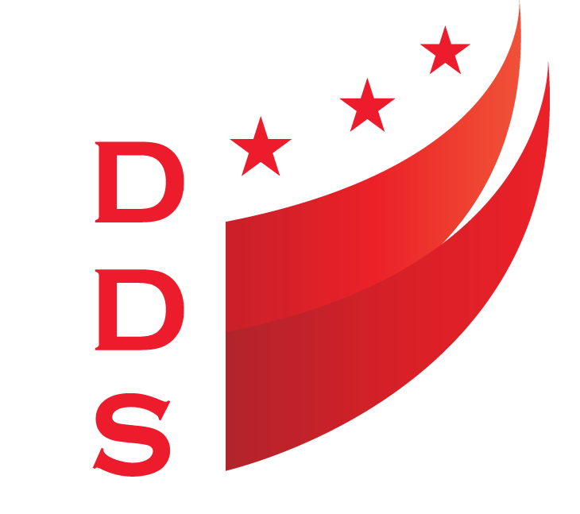
DEPARTMENT ON DISABILITY SERVICES
PRESS RELEASE

September 9, 2019 Contact: Jocelyn Harris, Public Information Specialist
C: 202-664-2162 jocelyn.harris2@dc.gov

District celebrates direct support professionals WEEK
Washington, DC—September 8 – 14, 2019 is National Direct Support Professionals (DSP) Week. An initiative of ANCOR and the National Association of Direct Support Professionals, this designation seeks to draw attention to and raise awareness about the vital role DSPs play in the lives of people with intellectual and developmental disabilities.
A Proclamation signed DC Mayor Muriel Bowser notes that “DSPs enhance the quality of life of people with disabilities by promoting self-determination, independence and safe-guarding their health and well-being.” On Thursday, September 12, the DC Coalition of Disability Service Providers will honor these dedicated professionals at its annual DSP Conference, which takes place at the Kellogg Conference Center on the campus Gallaudet University, 800 Florida Avenue, NW, at 8 a.m. This year’s theme is: DSPs – The District’s Rock Stars of Supports. Workshops include emerging technologies, disability policy developments, and fostering healthy relationships. Participants will be treated to a variety prizes and guest speakers as well.
According to the American Network of Community Options and Resources (ANCOR), nationwide more than one million individuals with disabilities rely on the services of Direct Support Professionals to live, work and thrive in their communities, and the demand is growing rapidly. To elevate the role of DSPs, ANCOR annually recognizes DSPs of the Year. Out of 350 nominations, the organization identified national and state-level DSPs that exemplified what it means to include, support, and empower people with intellectual disabilities. Linda Ballard, of RCM of Washington, is the 2019 DC DSP of the Year. She is credited with helping a person once thought unable to speak find his voice. Her supervisor commented that “Linda knows that with a little bit of trust, determination and hard work, anything was possible!”
In April, RCM of Washington launched the DSP Academy to equip people with disabilities with the skills and training necessary for a variety of career paths within the Health & Human services sector. DDS funds the DSP Academy. Director Andrew Reese commented that the program meets two goals: helping people with disabilities prepare for and obtain employment, and building and strengthening the DSP workforce. RCM is currently hosting its second DSP Academy.
Click here to view the Mayoral Proclamation.
Click here to learn more about the DSP Academy.

-30-

The Department on Disability Services is a dynamic organization serving people with disabilities through the services of was Developmental Disabilities Administration and the Rehabilitation Services Administration. This comprehensive collaborative approach provides innovative high quality services that enable people with disabilities to lead productive lives as vital members of their families, schools, workplaces, and communities. Learn more at www.dds.dc.gov and follow us at https://www.facebook.com/DDS.DC.

