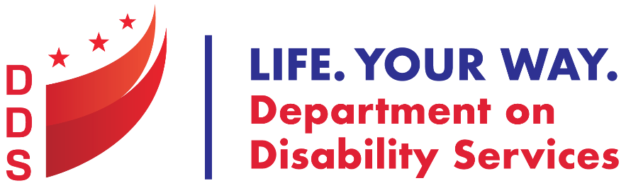

Press Release

DDS Celebrates Hispanic Heritage Month by Hosting Latinx Conference

Tuesday, September 28, 2021
Washington, DC— In recognition of National Hispanic Heritage Month, the DC Department on Disability Services will partner with the Mayor’s Office on Latino Affairs and various District government agencies to host the third annual Latinx Conference. This all-Spanish language event takes place Thursday, September 30, 10 am - 1 pm. People can participate in one of two ways: In-person at the Franklin D. Reeves Municipal Center, 2000 14th Street, NW, or virtually, via Zoom and on Facebook Live
The Latinx Conference seeks to provide Spanish speaking people with disabilities and their family members access to information, support, and resources in their native language while assisting District agencies in gaining a better understanding of needs and experiences of Latinos with disabilities. Conference topics include:
- Autism and other disabilities,
- Self-care and resilience, and
- The latest information about COVID-19.

Mary’s Center will also host a Pfizer vaccine clinic.

Click here to register for the event. All conference activities will be in conducted in Spanish. ASL and English interpretation will be available. For accommodations or questions, contact Mark.Agosto@dc.gov or 202-257-6698.
-30-
For more information, contact Public Information Specialist Jocelyn.Harris2@dc.gov or 202-664-2162

The Department on Disability Services is a dynamic organization serving people with disabilities through the services of the Developmental Disabilities Administration (DDA) and the Rehabilitation Services Administration (RSA). This comprehensive collaborative approach provides innovative high quality services that enable people with disabilities to lead productive lives as vital members of their families, schools, workplaces, and communities. Learn more at: www.dds.dc.gov and follow us on Twitter or Facebook.
