Project ACTION!
Nothing About Us Without Us

Come to the next Project ACTION! meeting!
Join with Project ACTION! members to change our communities for the better.

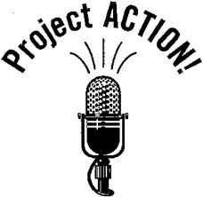
Saturday, May 11, 2019
Let Our Voices Be Heard
DC’s Self-Advocacy Coalition
10am — 12pm

Kennedy Institute
801 Buchanan Street NE
Washington, DC 20017

Hear about new policies at DDA and learn what your friends are doing.
Arrive on time and stay until the end. Light refreshments will be served.

Questions or need accommodations?
E-Mail Leonard Stevens at stevensleonard91@gmail.com or call Phyllis @ 202-270-1256`

