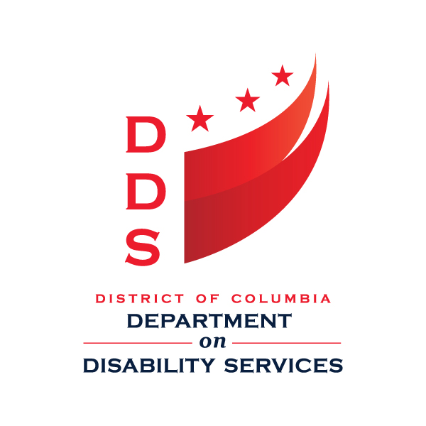**Government of the District of Columbia**

**Department on Disability Services**

**Presents:**



**COMMUNITY RESOURCE FAIR**

**Thursday, October 20, 2016**

**10 am - 8 pm**

The Walter E. Washington Convention Center

801 Mount Vernon Place, NW

Washington DC 20001

The Fair offers a unique opportunity for individuals with disabilities & families to learn about support services available from an array of Service Providers offering:

• Adult Day Services and Supports

* Transition Supports for Students and Youth

• Housing Services

• Clinical and Wellness Services

• Financial Literacy

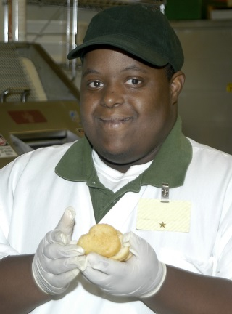• Employment Services

The day will include fun activities and interesting presentations such as:

* Pre-Employment Transition Supports
* Relaxation Techniques
* Benefits Planning Q & A
* Assistive Technology Presentations
* Customized Employment
* Apprenticeship Programs
* Finding Your Voice: Developing Self-Advocacy Skills
* Accessing Services though the Aging and Disability Resource Center
* Soft Skills for Employment Success



For more information, contact Alonzo Brown at 202-368-7093 or Alonzo.brown@dc.gov.