Come Hang Out with Project ACTION!

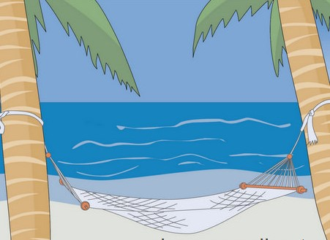
Come Hear About New Opportunities to Improve and Learn New Advocacy Skills

Saturday, June 18, 2016
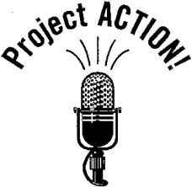
10:00am — 12:00pm
Let Our Voices Be Heard
DC’s Self-Advocacy Coalition

Kennedy Institute
801 Buchanan Street NE
Washington, DC 20017

Advocacy on the Move:
Come to our Meeting and Learn How You Can Grow as a
Self-Advocate!
Arrive on Time and Stay until the End
You Might Win the Lottery!
Light Refreshments will be served!
We want to see you there!
Questions or need accommodations? Call Heidi Case at 202-627-2123 or email her at hacase60@yahoo.com.

