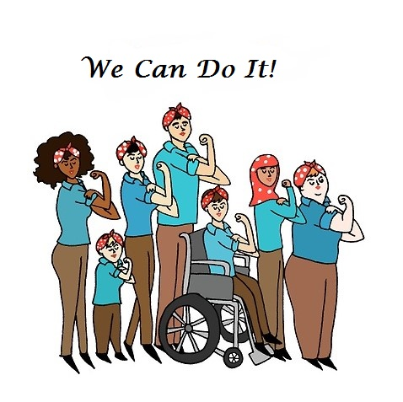

2015 Disability Support Professionals Conference

Sponsored in partnership by the
DC Coalition of Providers for Persons with Intellectual and Developmental Disabilities
DC Department on Disability Services
and
Quality Trust for Individuals with Disabilities

Conference Sponsorship Opportunities
Become a sponsor and be recognized as a proponent of professional development for disability support professionals.

Sponsorship levels available
Gold - $1,500
($1,600 Non Coalition Member rate)
Seven (7) free conference registrations
Company name/logo on conference promotional materials and tote bag
Company name/logo on event signage
Acknowledgment during program and company name on learning materials
Company name announced at event

Silver - $1250
($1350 Non Coalition Member rate)
Five (5) free conference registrations
Company name on conference promotional materials and tote bag
Company name on event signage
Acknowledgment during program and company name on learning materials
Company name announced at event

Bronze - $1000
($1100 Non Coalition Member rate)
Four (4) free conference registrations
Company name on conference promotional materials
Acknowledgment during program and company name placed on learning materials
Company name announced at event
Sponsorship Terms & Conditions:
- To receive recognition in all the 2015 registration materials, sponsorships must be reserved by Sept., 1, 2014.
- All payments received are non-refundable.
For more information about these and other sponsorship opportunities, please contact Danielle Darby, Chief Operations Officer at ddarby@rcmofwashington.com or 202-789-1930

Conference Sponsorship Form

Name of organization (as it should appear in materials):_______________________________________________________

Address:________________________________________________________ Suite or Room #:_____________

City:___________________________________________ State: ______________ Zip:___________________

Executive Director/CEO: _________________________________________________________________________

Sponsorship Contact:____________________________________________________________________________

Sponsorship Level: Gold $ 1,500:______ Silver $ 1250:______ Bronze $ 1000:______
Non-Coalition Member Rate: $ 1,600______ $ 1350 ______ $ 1100______

Paragraph about your organization or mission statement: (For Gold and Silver sponsors only, limit 50 words)

____________________________________________________________________________________________________________________________

___________________________________________________________________________________________________________________________

____________________________________________________________________________________________________________________________

___________________________________________________________________________________________________________________________

____________________________________________________________________________________________________________________________

Name of attendees included with your sponsorship: (Gold 7 attendees/ Silver 5 attendees/ Bronze 4 attendees)

- ________________________________________________________

- ________________________________________________________

- ________________________________________________________

- ________________________________________________________

- ________________________________________________________

- ________________________________________________________

- ________________________________________________________

- ________________________________________________________

Please mail your completed form and payment to (make checks payable to: DC Coalition)

United Cerebral Palsy
Attn: Kathleen Bjerknes, Treasurer
3135 8th Street, NE
Washington, DC 20017

Gold level sponsors please send an electronic version of your logo of your organization as PDF or eps. file
and email to pholton@dcqualitytrust.org

